Albania
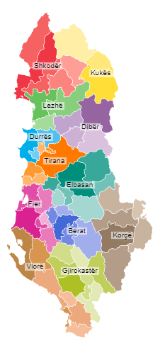
Chronology
c.500 BC - 146 BC Part of Epirus (Ípeiros/Épeiros).
146 BC - 17 Jan 395 AD Part of the Roman Empire.
17 Jan 395 Part of the Eastern (Byzantine) Roman Empire.
c.809 Organized as separate theme of Dyrrachion (théma
Dyrráchion).
986 - 1005 Bulgarian occupation.
1005 - 1203 Byzantine Empire rule (restored).
118. - 1256 An Albanian principality in Árvanon/Arbër (Arbanon)
(at Krujë in modern central Albania) autonomous
under Byzantine (from 1203, Epirus) rule.
1203 - 1213 Venetian rule (Duchy of Durazzo [Duchi di Durazzo]).
1213 - 1230 Despotate of Epirus (Ípeiros) suzerainty.
1230 - 1240 Under Bulgarian suzerainty.
1240 - 1256 Despotate of Epirus (Ípeiros) suzerainty.
1256 - 1258 Byzantine (Nicean) occupation.
1257 - 1272 Sicily ("Naples") occupies coastal parts of Albania
with headquarters at Durrachium/Durazzo/Durrësi,
under suzerainty of Epirus.
1258 - 21 Feb 1272 Part of Despotate of Epirus.
27 May 1267 Claim over Albania ceded from Byzantine Empire to
Sicily ("Naples") by treaty.
21 Feb 1272 Kingdom of Albania (Regnum Albaniae); Sicilian
domains are formally separated from Epirus under
the rule of Sicily ("Naples").
1286 - 1296 Byzantine occupation (of Durazzo/Durrësi from 1288).
13 Aug 1294 Son of king of Sicily ("Naples") invested with Anjou
possessions and claims in Albania and Greece
(effected 9 Oct 1304 by take-over).
1296 - 9 Oct 1304 Part of Serbia.
9 Oct 1304 Kingdom of Albania (re-established) under lordship
of junior members of the Neapolitan royal house
who use title "Lords of the Kingdom of Albania."
17 Dec 1332 Exchanged with Achaia by agreement (ratified 14 Mar
1338 by Sicily). With the Kingdom of Albania
greatly reduced in size, the new rulers adopt the
style Dux Duracii ("Duke of Durazzo").
Mar 1368 Anjou are ousted by force by Karl Topia who makes
Durazzo/Durrësi part of his enlarged domain. He
is styled Albaniae princeps et Durachii dominus
("Prince of Albania and Lord of Durazzo").
1376 - 1377 Durazzo occupied by the Navarese Company.
28 May 1386 - 28 Jun 1797 Butrinto/Bouthrotó/Butrint under Venetian rule,
under Corfu (Ottoman occupied 1655-1660).
18 Aug 1392 - 17 Aug 1501 Durazzo/Durrësi ceded to Venice, administered as
part of Albania Veneta (see under Montenegro)
14 Apr 1396 - 26 Jan 1479 Scutari/Skadar/Shkodra ceded to Venice.
1417 Ottoman Empire rule as Arvanid (Albanian) sanjak
(sancak-i Arvanid)(by submission), within Eyalet
of Rumelia.
Jun 1417 Ottomans take Valona/Avlóna/Vlorë/Avlonya.
28 Nov 1443 Albanian uprising launched by regional alliance.
2 Mar 1444 - 15 Jun 1478 Albania League (in Lezha) in central Albania, a
confederation of Albanian principalities in
revolt against Ottoman rule.
Jul 1466 Split into Avlona (Avlonya) and Elbasan (İlbasan)
sanjaks as part of Rumelia Eyalet (see Bulgaria).
15 Jun 1478 Kruja/Krujë part of the Ottoman Empire.
26 Jan 1479 Shkodra/Ishkodra/Skadar/Scutari part of the Ottoman
Empire.
17 Aug 1501 Durrësi/Durazzo part of the Ottoman Empire.
18 Sep 1690 - 6 Mar 1691 Valona/Avlóna/Vlorë occupied by Venice.
1691 Center of the sanjak of Avlona (Avlonya) relocated
to Berat and the sanjak was gradually renamed as
sanjak of Berat.
1768 - Oct 1831 Ishkodra (Işkodra) Pashalik autonomous.
1774 - 1808 Separate Berat Pashalik semi-autonomous in central
Albania (from 1808, annexed to Yanya [Janina]).
28 Jun 1797 - 26 Oct 1798 Butrinto/Butrint occupied by France.
21 Jan 1867 Area separated from Rumelia as vilayet of Uskudar
(Üsküdar vilayeti).
4 Sep 1912 Ottoman Empire grants autonomy by the Agreement of
Skopje (New Style date 17 Sep 1912)(not effected).
28 Nov 1912 Independence proclaimed (Albania [Shqipëri])
(O.S. 15 Nov 1912).
29 Nov 1912 - Apr 1913 Drač (Durrësi), Elbasan, Lješ (Lezha), and Tirana
annexed by Serbia as Drač County (Drački okrug)
(O.S. date 16 Nov 1912).
Dec 1912 New Style (Gregorian) calendar adopted.
24 Apr 1913 - 14 May 1913 Shkodra/Shkodër occupied by Montenegro.
14 May 1913 - 21 Aug 1914 Shkodra under International military administration.
30 May 1913 Autonomy granted to Albania by Allies.
29 Jul 1913 Independence as a principality by statute adopted by
conference of ambassadors in London (effected on
7 Mar 1914).
16 Oct 1913 International Control Commission established.
22 Jan 1914 Provisional government resigns under pressure,
International Control Commission takes over.
7 Mar 1914 Prince Wied-Neuwied takes over, the formal state
name remains Albania (Shqipëri) rather than
Principality of Albania (Principata Shqiptare).
10 Apr 1914 Organic Statute of Albania (Statuti Organik i
Shqipërisë) promulgated.
3 Sep 1914 Prince departs for Venice, handing over power to
an International Control Commission.
27 Oct 1914 - 15 Nov 1916 Greek administration of Northern Epirus.
28 Dec 1914 - 3 Sep 1920 Valona/Vlora occupied by Italy.
26 Apr 1915 In (secret) Treaty of London the Allies promise
Italy, Valona/Vlora and protectorate over Albania.
27 Jun 1915 - 23 Jan 1916 Shkodra re-occupied by Montenegro.
3 Jan 1916 - 13 Nov 1918 Occupied by Austria-Hungary (from 23 Jan 1916 in
Shkodra, 9 Feb 1916 Tirana, and 27 Feb 1916 Durrës)
and Bulgaria (in east 10 Dec 1915 - 9 Sep 1917).
24 Mar 1916 Albanian government forced into exile.
15 Nov 1916 - 26 May 1920 Korça occupied by France (autonomous 1916-1918).
10 Dec 1916 France proclaims an Autonomous Albania under a
French protectorate.
3 Jan 1917 Independence of Albania under Austro-Hungarian
protection declared by Austria-Hungary.
3 Jun 1917 Independence of all Albania under Italian
protectorate proclaimed by Italy.
14 Oct 1918 - 3 Sep 1920 Durazzo/Durrësi (and from 15 Oct 1918 Tirana)
occupied by Italy following Austrian withdrawal
in wake of military collapse of Bulgaria.
31 Oct 1918 - 11 Mar 1920 Shkodra occupied by Allied military forces.
25 Dec 1918 Provisional government elected in Durrës by a
congress.
30 Jan 1920 Statute of Lushnja (Statut i Lushnjës) adopted, High
Council established (by congress at Lushnja). The
Statute is extended by parliament on 8 Dec 1922
(Albanian State [Shtet Shqiptar]).
11 Mar 1920 French forces in Shkodra evacuated, Shkodra district
incorporated into Albania.
26 May 1920 Korça district incorporated into Albania (French
forces withdrawn 21 Jun 1920).
17 Ju1 1921 - 9 Aug 1921 Rebellion in North Central Albania (see Mirditë).
2 Aug 1920 Independence recognized by Italy, protectorate is
relinquished effective 5 Aug 1920. Last Italian
forces evacuated on 3 Sep 1920 (except for Saseno/
Sazan Island).
1 Nov 1921 - 20 Nov 1921 North central Albania occupied by Yugoslavia.
9 Nov 1921 Conference of Ambassadors of the Principal Allied and
Associated Powers confirms the independence of
Albania within the frontiers of 1913 and the
'special interest' of Italy in 'protecting' it.
31 Jan 1925 Albanian Republic (Republika Shqiptare)(by
proclamation of 21 Jan 1925).
27 Nov 1926 Italo-Albanian Alliance and Security Treaty of
Tirana signed (along with 15 Mar 1925 convention
and 22 Nov 1927 treaty, Albania becomes a de facto
protectorate of Italy).
1 Sep 1928 Albanian Kingdom (Mbretëri Shqiptare [in Gheg Albanian:
Mbretnija Shqiptare]).
8 Apr 1939 Italian invasion.
12 Apr 1939 Kingship offered to the King of Italy (accepted 16 Apr 1939,
effective on 23 Apr 1939 by viceroy take-over).
23 Apr 1939 - 3 Sep 1943 Personal union with Italy (de facto annexation): Kingdom
of Albania (Mbretni e Shqipnisë [Regno d'Albania]).
8 Dec 1940 - 24 Apr 1941 Greek occupation of Northern Epirus (see below).
10 Jul 1941 - 20 Oct 1944 Kosovo, parts of western Macedonia (Kičevo, Debar,
Tetovo, and Struga), and from 3 Dec 1941 parts of
Montenegro (Bar, Gusinje Plav, Peć, and Ulcinj)
are annexed to Albania. From Sep 1944, Kumanovo
and surroundings in former Bulgarian occupied
Macedonia are also annexed to Albania.
9 Sep 1943 - 17 Nov 1944 German occupation (last forces expelled 29 Nov 1944).
14 Sep 1943 Independence declared (Albanian State [Shtet
Shqiptar])(recognized by Germany on 13 Jul 1944).
27 May 1944 Anti-Fascist Council of National Liberation (Komitet
Antifashist Nacional-Çlirimtar) established in
rebellion.
22 Oct 1944 Democratic Government of Albania (Qeveri Demokratike
të Shqipërisë), in opposition to German occupation
until 17 Nov 1944.
28 Nov 1944 Tiranë under Communist control (by take-over).
11 Jan 1946 People's Republic of Albania (Republika Popullore
e Shqipërisë).
28 Dec 1976 People's Socialist Republic of Albania (Republika
Popullore Socialiste e Shqipërisë).
29 Apr 1991 Republic of Albania (Republika e Shqipërisë).
16 Apr 1997 - 12 Aug 1997 Multinational Protection Force deployed in Albania to
stabilize country following an economic collapse.
6 Jul 1997 Referendum rejects restoration of monarchy by 66%.
Note: dates before 1912 are given according to Old Style (Julian) calendar, and after according to New Style (Gregorian) calendar. New Style was formally introduced in Albania Dec 1912.
Archons (Árchontes)¹ (in Kruja/Krujë)
(Greek names with Albanian in parentheses)
118. - c.1198 Prógonos (Progon) (b. 11.. - d. c.1198)
c.1198 - 1208 Gínis (Gjin) (b. 11.. - d. 1208)
1208 - 1216 Dimítrios (Dhimitër Progoni) (b. 11.. - d. 1216)
1216 - 12.. Grigórios Kamonás (Grigor Kamona)
12.. - 1256 Goulámos (Golem)
Greek Commander
1256 - 1258 Konstantínos Chaváron
1258 - 21 Feb 1272 part of Epirus
Kings of Albania¹
Feb 1272 - 1286 the kings of Sicily ("Naples")
1286 - 1296 Byzantine rule
1296 - 9 Oct 1304 part of Serbia
Sicilian Captains and Vicars-general in the Kingdom of Albania¹ (in Durrachium/Durrësi)
25 Feb 1272 - May? 1273 Gazzo Chinardo
May? 1273 - Mar? 1274 Anselme de Caen (Chaus) (b. 12.. - d. 1274)
Mar? 1274 - May 1274 Johannes de Bussiaco (acting)
May 1274 - Oct 1275 Narzone de Tuziaco (Toucy)
Oct 1275 - Oct 1277 Guillelmo Bernardi (1st time)
(Guillaume Bernard)
Oct 1277 - Jun? 1279 Johan (Jean) de Vaubecourt
Jun? 1279 - 1282 Johan Scocto (Jean Scotto)
1282 - 1286 Guillelmo Bernardi (2nd time)
Lords of the Kingdom of Albania¹ (in Durazzo/Durrësi)
(Italian names with French in parentheses)
9 Oct 1304 - 26 Dec 1331 Filippo, principe di Taranto
(6 Oct 1304 - 29 Jul 1313, e Acaia) (Philippe, prince de Tarente et d'Achaïe)
(b. 1278 - d. 1331)
26 Dec 1331 - 17 Dec 1332 Roberto, principe di Taranto
(Robert, prince de Tarente)
(b. 1326 - d. 1364)
26 Dec 1331 - 17 Dec 1332 Caterina (f) -Regent (Cathérine de Valois)
(b. 1303 - d. 1346)
Dukes of Durazzo, Lords of the Kingdom of Albania¹ (in Durazzo/Durrësi)
(Italian names with French in parentheses)
17 Dec 1332 - 1. May 1335 Giovanni (Jean de Gravina) (b. 1294 - d. 1335)
1. May 1335 - 22 May 1348 Carlo (Charles) (b. 1323? - d. 1348)
18 Jul 1337 - 22 May 1346 Ludovico (Louis)(acting) (b. 1327 - d. 1362)
(vicar and captain-general)
22 May 1348 - Mar 1368 Giovanna (Jeanne)(f) -Duchess (b. 1344 - d. 1387)
- jointly with -
19 Jun 1366 - Mar 1368 Ludovico (Louis d'Évreux) (b. 1341 - d. 1372)
Princes of Albania and Lords of Durazzo¹ (in Durazzo/Durrësi)
(Albanian names with Greek in parentheses)
Mar 1368 - Jan 1388 Karl Andreas Topia (b. 134. - d. 1388)
(Károlos Andréou "o Theopías")
1383 - 18 Sep 1385 Balša Balšić Zetskoi (b. 133. - d. 1385)
(pretender, in dissidence)
Jan 1388 - 18 Aug 1392 Gjerj Karl Topia (b. 137. - d. 1392)
(Geórgios Karólou "o Theopías")
18 Aug 1392 - 1417 Venetian rule
1417 - 2 Mar 1444 Turkish rule
Captains-general of the Albania League (in Kruja/Krujë)
(Albanian names with Greek in parentheses)
2 Mar 1444 - 17 Jan 1468 Gjergj Gjon Kastrioti (b. 1406 - d. 1468)
(Geórgios Ioánnou Kastriótis)
(from c.1459, Iskandar Beg "Skanderbeg")
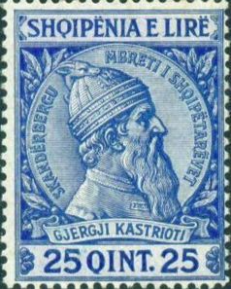 | 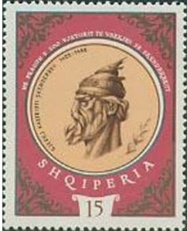
17 Jan 1468 - 15 Jun 1478 Gjon Gjergj Kastrioti (b. 144. - d. af.1495)
(Giánnis Georgíou Kastriótis)
Ottoman Sanjakbeys of Arvanid (Albania)
1417 - 1437 ....
bf.1432 Ali Bey Evrenosoğlu
1437 Yakup Bey (Jakup Beu)(1st time) (d. 1442)
1437 - 1439 Hadim Shehabeddin Pasha (d. 1453)
1441 - Sep 1442 Yakup Bey (Jakup Beu)(2nd time) (s.a.)
1442 - 1466 ....
Ottoman Sanjakbeys of Avlonya (Valona/Vlorë)
1466 - 1774 ....
1479 Gedik Ahmed Pasha
1506 Bali Bey
1516 Mehmed Beg Isaković
bf.1570 Muzaffer Pasha
15.. - 16.. Mustafa Pasha (Bin Abdullah)
1712 - 1714 Sari Ahmed Pasha
1714 - 1774 ....
Walis of Yanya (Janina)
1670 - 1911 see under Greece
Walis of Ishkodra (Shkodra/Shkodër)
1479 - 173. ....
1496 - 1502 Firuz Bey Mihaloğlu
c.1604 Ali Bey
c.1614 Mehmed Bey Ballichienovich
(Balicenovic)
1683? - 1692 Süleyman Pacha Bushatli
1693 - .... Ali Pasha
173. - 173. Hodaverdi
173. - 1740 Süleyman Pasha Çausholli
1740 - 1747 Jusuf Pasha Çausholli
1746 Mehmet Bushatli (in rebellion)
1747 - 1755 ....
1755 - 1768 Ömer Pasha Kavajë
Pashas of Ishkodra
1768 - 1774 Mehmed Pasha Bushati (d. 1774)
1774 - 1778 Mustafa Pasha Bushati (d. 1778)
1778 - 22 Sep 1796 Kara Mahmud Pasha Bushati (b. c.1749 - d. 1796)
22 Sep 1796 - 1810 Ibrahim Pasha Bushati (d. 1810)
1810 - 9 Oct 1831 Mustafa Reshit Pasha Bushati (b. 1797 - d. 1860)
Pashas of Berat
1774 - 1787 Ahmet Kurt Pasha (d. 1787)
1787 - 1808 Ibrahim Pasha
Walis of Ishkodra (Shkodra/Shkodër/Üsküdar)
1831 - 1832 Morali Namik Ali Pasha
1833 - 1835 Çerkes Hafiz Pasha
1835 - 1838 Bayram Beg
1838 - 1842 Hasan Pasha
1842 - 1843 Reza Pasha
1843 - 1854 Osman Mazhar Pasha
Jul 1854 - Sep 1854 Osman Pasha
Sep 1854 - Jan 1855 Sarayli Mehmed Ragib Pasha
Jan 1855 - Mar 1855 Hekimbashi Ismail Pasha
Apr 1855 - Dec 1855 Agha Abdulaziz Pasha (d. 1855)
Dec 1855 - Nov 1857 Ataullah Pasha
Nov 1857 - Oct 1861 Çerkes Abdi Pasha (1st time)
Oct 1861 - Apr 1862 Mehmed Rashid Pasha
Apr 1862 - Apr 1863 Çerkes Abdi Pasha (2nd time)
Apr 1863 - Dec 1864 Aziz Pasha
Dec 1864 - May 1868 Divitçi Ismail Hakki Pasha (1st time)
May 1868 - Dec 1868 Kücük Omer Fevzi Pasha (b. 1818 - d. 1878)
Dec 1868 - Aug 1870 Sakizli Ahmed Esad Pasha
Aug 1870 - Sep 1871 Divitçi Ismail Hakki Pasha (2nd time)
Sep 1871 - Jan 1872 Giritli Mustafa Asim Pasha (1st time)
Apr 1872 - Jan 1873 Sevket Pasha
Jan 1873 - Mar 1873 Fosfor Mustafa Sidki Pasha
Mar 1873 - May 1873 Gürcü Ali Pasha
May 1873 - 7 Nov 1873 Sevket Pasha (d. 1873)
Nov 1873 - Sep 1874 Ahmed Razim Pasha (b. 1826 - d. 1897)
Oct 1874 - May 1876 Mustafa Eshref Pasha (d. 1873)
May 1876 - Aug 1876 Yakali Ali Pasha (d. 1876)
Aug 1876 - Jul 1878 Alyanak Mustafa Pasha (d. 1884)
1878 Hüseyin Pasha
Nov 1878 - Nov 1879 Arif Pasha
Nov 1879 - Aug 1880 Mehmed Izzet Pasha
Aug 1880 - Apr 1882 Çürüksulu Osman Ziya Pasha (d. 1908)
Apr 1882 - Jul 1883 Abdi Pasha
Aug 1883 - May 1884 Hasan Pasha
May 1884 - Jan 1887 Giritli Mustafa Asim Pasha
(2nd time)
Jan 1887 - Aug 1888 Tahir Pasha (d. 1913)
Aug 1888 - Jan 1891 Çürüksulu Süleyman Bahri Pasha (b. 1840 - d. 1915)
Oct 1891 - Jul 1894 Bursali Abdülkerim Pasha (b. 1839 - d. 1912)
Jul 1894 - Jun 1896 Osman Fevzi Pasha (d. 1924)
Jun 1896 - Jul 1898 Hasan (Edip) Adib Pasha (b. 1834 - d. 1904)
Jul 1897 - Nov 1901 Alpa Kazim Pasha (b. 1839 - d. 1936)
Nov 1901 - May 1903 Shakir Pasha
May 1903 - Apr 1906 Haydar Pasha
Apr 1906 - Feb 1907 Salih Sekki (Zeki) Pasha (b. 1848 - d. 1908)
Feb 1907 - Dec 1907 Hilmi Pashaa
Dec 1907 - Feb 1908 Dagistanli Seyfullah Pasha
Jun 1908 - Sep 1908 Mustafa Nuri Bey (b. 1851 - d. 1923)
Sep 1908 - Dec 1908 Yenisher Fenerli Seyfettin Bey (b. 1860 - d. 1938)
Dec 1908 - May 1909 Fahri Pasha
May 1909 - Sep 1910 Agabeyzade Çemal Pasha (b. 1872 - d. 1922)
Sep 1910 - May 1911 Manastırlı Hasan Bedrieddin Beg (b. 1850 - d. 1912)
May 1911 - Jan 1912 Mustafa Nedim Beg
Jan 1912 - Mar 1912 Hayri Pasha
Mar 1912 - 30 Jan 1913 Hasan Riza Pasha (b. 1871 - d. 1913)
Apr 1912 - 23 Aug 1912 Hasan Bej Prishtina (in rebellion) (b. 1873 - d. 1933)
Serbian District Chiefs of Drač County (Drački okrug)(in Drač/Durrësi)
29 Nov 1912 - 1912 Ivan Ivanić (b. 1867 - d. 1935) Non-party
1912 - Apr 1913 Dragutin Anastasijević (b. 1877 - d. 1950) Non-party
Chairman of the National Assembly (in Vlora)
28 Nov 1912 Ismail Mahmut Qemali Bej Vlora (b. 1844 - d. 1919) Lib
Chairman of the Provisional Government (in Vlora)
28 Nov 1912 - 22 Jan 1914 Ismail Mahmut Qemali Bej Vlora (s.a.) Lib
INCLUDEPICTURE "http://i1078.photobucket.com/albums/w488/bardhi86/Ismael-Qemali.jpg" \* MERGEFORMATINET INCLUDEPICTURE "http://i1078.photobucket.com/albums/w488/bardhi86/Ismael-Qemali.jpg" \* MERGEFORMATINET INCLUDEPICTURE "http://i1078.photobucket.com/albums/w488/bardhi86/Ismael-Qemali.jpg" \* MERGEFORMATINET INCLUDEPICTURE "http://i1078.photobucket.com/albums/w488/bardhi86/Ismael-Qemali.jpg" \* MERGEFORMATINET INCLUDEPICTURE "http://i1078.photobucket.com/albums/w488/bardhi86/Ismael-Qemali.jpg" \* MERGEFORMATINET INCLUDEPICTURE "http://i1078.photobucket.com/albums/w488/bardhi86/Ismael-Qemali.jpg" \* MERGEFORMATINET INCLUDEPICTURE "http://i1078.photobucket.com/albums/w488/bardhi86/Ismael-Qemali.jpg" \* MERGEFORMATINET INCLUDEPICTURE "http://i1078.photobucket.com/albums/w488/bardhi86/Ismael-Qemali.jpg" \* MERGEFORMATINET INCLUDEPICTURE "http://i1078.photobucket.com/albums/w488/bardhi86/Ismael-Qemali.jpg" \* MERGEFORMATINET INCLUDEPICTURE "http://i1078.photobucket.com/albums/w488/bardhi86/Ismael-Qemali.jpg" \* MERGEFORMATINET 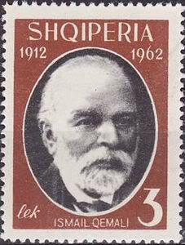
12 Oct 1913 - 12 Feb 1914 Esat Ali Pashë Toptani Non-party
(chairman of Council of Elders of Central Albania,
in dissidence in Durrësi) (b. 1863 - d. 1920)
22 Jan 1914 - 7 Mar 1914 International Commission of Control (in Durrësi)
- Léon Alphonse Thaddé Krajewski (b. 1863 - d.af.1931) (Krajevsky)(France)
- Harry Harling Lamb (U.K.) (to Aug 1914) (b. 1857 - d. 1948)
- Alessandro di Luigi Leoni (Italy) (to Aug 1914) (b. 1852 - d. 1918)
- Aleksandr Mikhaylovich Petryayev (Russia) (b. 1875 - d. 1933)
- Aristoteles (Aristotel) Petrović (Austria-Hungary)(to 24 Feb 1914) (b. 1868 - d. 19..) - August Kral (Austria-Hungary) (from 24 Feb 1914) (b. 1869 - d. 1953)
- Julius Winckel (Germany) (to 6 Aug 1914) (b. 1857 - d. 1941)
- Rudolf Nadolny (Germany) (acting for Winckel 31 Jan - 18 Jun 1914)
(b. 1873 - d. 1953)
- Ahmet Myfit Neki Bej Libohova (Albania)(to 17 Mar 1914) (b. 1876 - d. 1927)
- Mehdi Abdyl Bej Frashëri (Albania)(17 Mar - 3 Sep 1914) (b. 1872 - d. 1963)

First secretaries of the Albanian Communist Party (from Nov 1948, Albanian Party
of Labour)
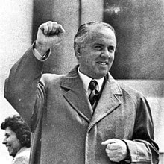 | 8 Nov 1941 - 11 Apr 1985 Enver Hoxha  (b. 1908 - d. 1985)  (until Mar 1943 secretary;  Mar 1943 - 17 Jul 1954 general secretary)
11 Apr 1985 - 13 Apr 1985 Vangjel Çërrava
(b. 1941)
+ Lenka Çuko (f) (b. 1938)
+ Simon Stefani (b. 1929 - d. 2000) (secretaries)
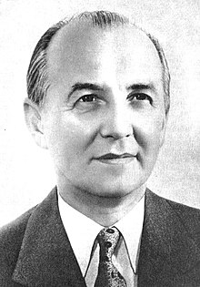 | 13 Apr 1985 - 4 May 1991 Ramiz Alia  (b. 1925 - d. 2011)
Chairman of the National Assembly
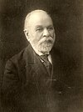 | 28 Nov 1912 - 29 Nov 1912 Ismail Qemali Bej  (b. 1844 - d. 1919)
Chairman of the Provisional Government
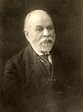 | 29 Nov 1912 - 22 Jan 1914 Ismail Qemali Bej (s.a.)
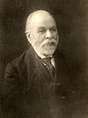
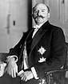 | 12 Oct 1913 - 12 Feb 1914 Esat Pashë Toptani  (b. 1863 - d. 1920)  (chairman Council of Elders of Central Albania,  in opposition in Durrës)
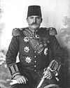
Chairman of the Central Government
22 Jan 1914 - 7 Mar 1914 Fejzi Bej Alizoti
(b. 1876 - d. 1945)
Prince of modern Albania (1914)
Sovereign Prince
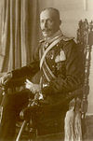 | 7 Mar 1914 - 3 Sep 1914 Wilhelm zu Wied  (b. 1876 - d. 1945)
 |  |  | 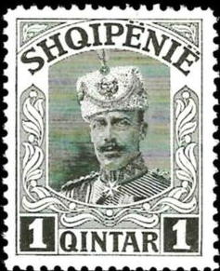
Chairman of the Administrative Commission
 | 3 Sep 1914 - Sep 1914 Qamil Musa Haxhi Feza
Chairman of the General Council
 | Sep 1914 - 5 Oct 1914 Mustafa Bej Ndroqi
Chairmen of the Provisional Government
 | 5 Oct 1914 - 24 Feb 1916 Esat Pashë Toptani (s.a.)
 | 24 Feb 1916 - 28 Dec 1918 no national government
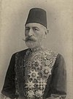 | 28 Dec 1918 - 28 Jan 1920 Turhan Pashë Përmeti  (b. 1839? - d. 1927)
Chairman of the National Government
28 Jan 1920 - 30 Jan 1920 Sulejman Bej Delvina (b. 1884 - d. 1932)
INCLUDEPICTURE "http://i.colnect.net/images/b/2393/814/Sulejman-Pasha-Delvina.jpg" \* MERGEFORMATINET INCLUDEPICTURE "http://i.colnect.net/images/b/2393/814/Sulejman-Pasha-Delvina.jpg" \* MERGEFORMATINET INCLUDEPICTURE "http://i.colnect.net/images/b/2393/814/Sulejman-Pasha-Delvina.jpg" \* MERGEFORMATINET INCLUDEPICTURE "http://i.colnect.net/images/b/2393/814/Sulejman-Pasha-Delvina.jpg" \* MERGEFORMATINET INCLUDEPICTURE "http://i.colnect.net/images/b/2393/814/Sulejman-Pasha-Delvina.jpg" \* MERGEFORMATINET INCLUDEPICTURE "http://i.colnect.net/images/b/2393/814/Sulejman-Pasha-Delvina.jpg" \* MERGEFORMATINET INCLUDEPICTURE "http://i.colnect.net/images/b/2393/814/Sulejman-Pasha-Delvina.jpg" \* MERGEFORMATINET INCLUDEPICTURE "http://i.colnect.net/images/b/2393/814/Sulejman-Pasha-Delvina.jpg" \* MERGEFORMATINET INCLUDEPICTURE "http://i.colnect.net/images/b/2393/814/Sulejman-Pasha-Delvina.jpg" \* MERGEFORMATINET INCLUDEPICTURE "http://i.colnect.net/images/b/2393/814/Sulejman-Pasha-Delvina.jpg" \* MERGEFORMATINET 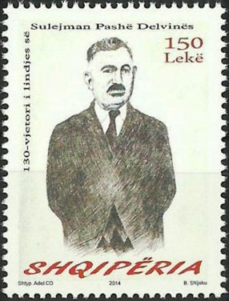
30 Jan 1920 - 25 Dec 1921 High Council
- Aqif Pashë Biçaku (b. 18... - d. 1926) (to 22 Dec 1921)
- Luigj Bumçi (b. 1872 - d. 1945) (to 22 Dec 1921)
- Abdi Bej Toptani (b. 1864 - d. 1942)
- Mihal Turtulli
25 Dec 1921 - 31 Jan 1925 High Council
- Omer Pashë Vrioni (to 22 Jan 1922)
- Ndoc Pistulli (to 22 Jan 1922)
- Sotir Peci (b. 1873 - d. 1932)
- Refik Bej Toptani
- Xhafer Bej Ypi (b. 1880 - d. 1940) (from 2 Dec 1922)
- Gjon Çoba (from 2 Dec 1922)
2 Jul 1924 - 24 Dec 1924 Fan Noli
(b. 1882 - d. 1965) (acting for High Council)
President
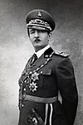 |  | 31 Jan 1925 - 1 Sep 1928 Amet Zogu  (b. 1895 - d. 1961)
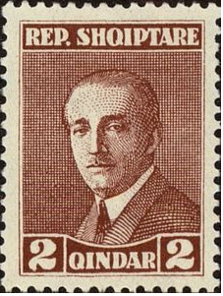 |  |  | 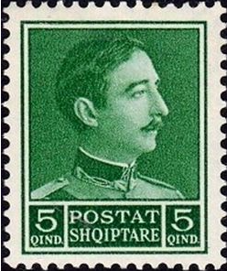
House of Zogu (1939–1945)
King of the Albanians (1928–1939)
Kings (title Mbret i Shqiptarëve; 1939-43 Mbret i Shqipërisë)
 |  | 1 Sep 1928 - 8 Apr 1939 Zog I (s.a.)
9 Apr 1939 - 12 Apr 1939 Xhafer Ypi (s.a.)
(chairman Provisional Administration Committee)
12 Apr 1939 - 16 Apr 1939 Shefqet Bej Vërlaci
(b. 1877 - d. 1946) (acting head of state)
Italian Occupation (1939–1943)
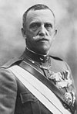 |  | 16 Apr 1939 - 3 Sep 1943 Vittorio Emanuele III  (b. 1869 - d. 1947) Lieutenants-general, representing Vittorio Emanuele III:
22 Apr 1939 - Mar 1943 Francesco Jacomoni di San
(b. 1894 - d. 1973)
Mar 1943 - Sep 1943 Alberto Pariani
(b. 1876 - d. 1955)
14 Sep 1943 - 20 Oct 1943 Ibrahim Bej Biçaku
(b. 1905 - d. 1977)
(chairman Provisional Executive Committee)
20 Oct 1943 - 25 Oct 1944 Mehdi Bej Frashëri
(b. 1872 - d. 1963)
(chairman High Council of Regency)
Chairmen of the Presidium of the People's Assembly
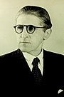 |  | 26 May 1944 - 1 Aug 1953 Omer Nishani  (b. 1887 - d. 1954)  (chairman Presidium of Anti-Fascist Council of National  Liberation to 12 Jan 1946; chairman Presidium of  Constituent Assembly 12 Jan - 14 Mar 1946)
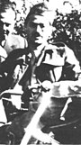 |  | 1 Aug 1953 - 22 Nov 1982 Haxhi Lleshi  (b. 1913 - d. 1998)
 |  | 22 Nov 1982 - 30 Apr 1991 Ramiz Alia (s.a.)
Presidents
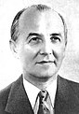 |  | 30 Apr 1991 - 3 Apr 1992 Ramiz  (s.a.)
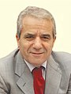 |  | 3 Apr 1992 - 6 Apr 1992 Kastriot Islami (acting)  (b. 1952)
- |  | 6 Apr 1992 - 9 Apr 1992 Pjetër Arbnori (acting)  (b. 1935 - d. 2006)
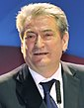 |  | 9 Apr 1992 - 24 Jul 1997 Sali Berisha  (b. 1944)
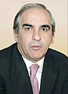 |  | 24 Jul 1997 (hours) Skënder Gjinushi (acting)  (b. 1949)
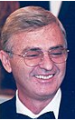 |  | 24 Jul 1997 - 24 Jul 2002 Rexhep Meidani  (b. 1944)
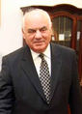 |  | 24 Jul 2002 - 24 Jul 2007 Alfred Moisiu  (b. 1929)
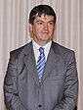 |  | 24 Jul 2007 - 24 Jul 2012 Bamir Topi  (b. 1957)
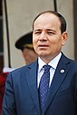 |  | 24 Jul 2012 - 24 Jul 2017 Bujar Nishani  (b. 1966)
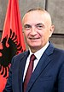 |  | 24 July 2017 – 24 July 2022 Ilir Meta  (b. 1969)
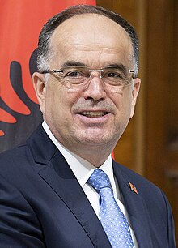 |  | Bajram Begaj 24 July 2022
Principality of Albania (1914–1925)
Prime ministers
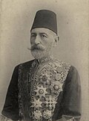 |  | 17 Mar 1914 - 3 Sep 1914 Turhan Pashë Përmeti  (s.a.)
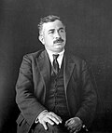 |  | 27 Mar 1920 - 14 Nov 1920 Sulejman Bej Delvina  (s.a.)
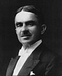 |  | 10 Dec 1920 - 19 Oct 1921 Iliaz Bej Vrioni  (1st time) (b. 1882 - d. 1932)
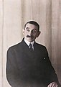 |  | 19 Oct 1921 - 6 Dec 1921 Pandeli Evangjeli  (1st time) (b. 1859 - d. 1949)
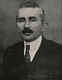 |  | 7 Dec 1921 - 12 Dec 1921 Hasan Bej Pristina  (b. 1873 - d. 1933)
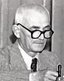 |  | 12 Dec 1921 - 30 Dec 1921 Idhomene Kosturi  (b. 1873 - d. 1943)
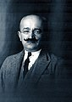 |  | 30 Dec 1921 - 4 Dec 1922 Xhafer Bej Ypi  (s.a.)
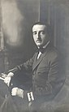 |  | 4 Dec 1922 - 5 Mar 1924 Amet Zogu  (1st time) (s.a.)
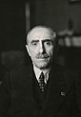 |  | 5 Mar 1924 - 2 Jun 1924 Shefqet Bej Vërlaci  (1st time) (s.a.)
2 Jun 1924 - 16 Jun 1924 Iliaz Bej Vrioni
(2nd time) (s.a.)
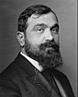 |  | 16 Jun 1924 - 26 Dec 1924 Fan Noli  (s.a.)
26 Dec 1924 - 6 Jan 1925 Iliaz Bej Vrioni
(3rd time) (s.a.)
6 Jan 1925 - 30 Jan 1925 Amet Zogu
(2nd time) (s.a.)
Albanian Kingdom (1928–1939)
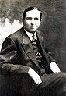 |  | 10 Sep 1928 - 5 Mar 1930 Koço Kota  (1st time) (b. 1889 - d. 1947)
5 Mar 1930 - 22 Oct 1935 Pandeli Evangjeli
(2nd time) (s.a.)
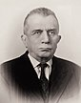 |  | 22 Oct 1935 - 9 Nov 1936 Mehdi Bej Frashëri  (s.a.)
9 Nov 1936 - 8 Apr 1939 Koço Kota
(2nd time) (s.a.)
Italian protectorate of Albania (1939–1943)
12 Apr 1939 - 4 Dec 1941 Shefqet Bej Vërlaci
(2nd time) (s.a.)
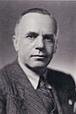 |  | 4 Dec 1941 - 19 Jan 1943 Mustafa Merlika-Kruja  (b. 1887 - d. 1958)
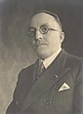 |  | 19 Jan 1943 - 13 Feb 1943 Eqrem Bej Libohova  (1st time) (b. 1882 - d. 1948)
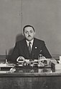 |  | 13 Feb 1943 - 12 May 1943 Maliq Bushati  (b. 1880 - d. 1946)
12 May 1943 - 9 Sep 1943 Eqrem Bej Libohova
(2nd time) (s.a.)
German occupation of Albania
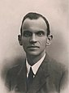 |  | 4 Nov 1943 - 18 Jul 1944 Rexhep Mitrovica  (b. 1888 - d. 1967)
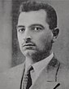 |  | 18 Jul 1944 - 7 Sep 1944 Fiqri Dine  (b. ... - d. 1960)
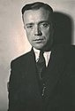 |  | 7 Sep 1944 - 26 Oct 1944 Ibrahim Bej Biçaku  (s.a.)
People's Republic of Albania
(1946–1976)
People's Socialist Republic of Albania
(1976–1991)
Chairmen of the Council of Ministers
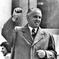 |  | 22 Oct 1944 - 20 Jul 1954 Enver Hoxha  (s.a.)
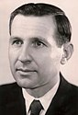 |  | 20 Jul 1954 - 18 Dec 1981 Mehmet Shehu  (b. 1913 - d. 1981)
18 Dec 1981 - 22 Feb 1991 Adil Çarçani
(b. 1922 - d. 1997) (acting to 15 Jan 1982)
Republic of Albania
Prime ministers
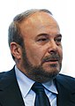 |  | 22 Feb 1991 - 5 Jun 1991 Fatos Nano  (1st time) (b. 1952)
 |  | 5 Jun 1991 - 10 Dec 1991 Ylli Bufi (b. 1948)
10 Dec 1991 - 13 Apr 1992 Vilson Ahmeti
(b. 1951)
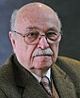 |  | 13 Apr 1992 - 11 Mar 1997 Aleksandër Meksi  (b. 1939)
 |  | 11 Mar 1997 - 24 Jul 1997 Bashkim Fino (b. 1962)
24 Jul 1997 - 2 Oct 1998 Fatos Nano
(2nd time) (s.a.)
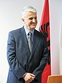 |  | 2 Oct 1998 - 29 Oct 1999 Pandeli Majko  (1st time) (b. 1967)
29 Oct 1999 - 22 Feb 2002 Ilir Meta
(s.a.)
22 Feb 2002 - 31 Jul 2002 Pandeli Majko
(2nd time) (s.a.)
31 Jul 2002 - 11 Sep 2005 Fatos Nano
(3rd time) (s.a.)
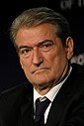 |  | 11 Sep 2005 - 15 Sep 2013 Sali Berisha  (s.a.)
 |  | 15 Sep 2013 - Edi Rama  (b. 1964)
Modern Noble and Ecclesiastical Titles: bej, beg = chieftain; conte = count; freiherr, barone = baron; marchese = marquess; principe, prinz = prince; mitropolit = metropolitan.
¹Full style of the ruler:
(a) 118. - 1256 (in Greek): Árchontes ("Rulers");
(b) Feb 1272 - 1286 (in Latin): Rex Albaniae ("King of Albania"), the royal Captains and Vicars-general were styled Capitanei et vicarii generales in regno Albaniae ("Captains and Vicars-general in the Kingdom of Albania");
(c) 9 Oct 1304 - 29 Jul 1313: Despot Romaniae et Dominus regni Albaniae ("Despot of from Romania and Lord of the Kingdom of Albania");
(d) 29 Jul 1313 - 17 Dec 1332: Constantinopolitani imperatores, Despoti Romaniae et Domini regni Albaniae ("Emperors of Constantinpole, Despots of Romania and Lords of the Kingdom of Albania);
e) 17 Dec 1332 - Mar 1368: Dux Duracii regni Albaniae et honoris Montis Sancti Angeli dominus ac Gravine comes ("Duke of Durazzo, Lord of the Kingdom of Albania and the fief of Monte Sant' Angelo [in Sicily "Naples"], as well as Count of Gravina");
( (f) Mar 1368 - 18 Aug 1392: Albaniae princeps et Durachii dominus ("Prince of Albania and Lord of Durazzo"), 1388-1392 dominus Durachii ("Lord of Durazzo");
(g) 7 Mar 1914 - 3 Sep 1914: formally Mbret i Shqipnis ("King of Albania"), semi-official and frequently informally Mbret i Shqiptarëve ("King of the Albanians"), Mbret internationally translated as "Prince." The Organic Statute of Albania promulgated by the International Commission of Control 10 Apr 1914 refers to the sovereign as Prince (original version of the Statute was drafted in French);
(h) 1 Sep 1928 - 8 Apr 1939: Mbret i Shqiptarëve ("King of the Albanians"). Sentences were passed in the name of Me vullnet të Popullit Mbret' i Shqiptarëvet ("By the will of the Nation, King of the Albanians");
(i) 23 Apr 1939 - 8 Sep 1943: Për Hir të Zotit e Për Vullnet të Kombit Mbret i Italis dhe (e) i Shqipnis Perandor i Etiopis ("By the Grace of God and the will of the Nation King of Italy and of Albania, Emperor of Ethiopia").
The use of the titles Re di Albania/Mbret i Shqipnis and Imperatore d'Etiopia/Perandor i Etiopis was informally discontinued after 23 Sep 1943; official change of the royal style was sanctioned by the decree of 27 Nov 1943 (period of application backdated to 8 Sep 1943; published in Italy Official Gazette, No. 4, 8 Dec 1943).
Territorial Disputes: None.
Party abbreviations: LSI = Lëvizja Socialiste për Integrim (Socialist Movement for Integration, social-democratic, pro-European, split from PSS, est.6 Sep 2004); PDS = Partia Demokratike e Shqipërisë (Democratic Party of Albania, conservative, center-right, est.12 Dec 1990); PSS = Partia Socialiste e Shqipërisë (Socialist Party of Albania, social-democratic, center-left, former PPS, est.5 Jun 1991); Mil = Military;
- Former parties: BK = Balli Kombëtar (National Front, Albanian nationalist, anti-communist, Nov 1942-1944); Con = Conservative; GSHM = Garda e Shqipërisë së Madhe (Guard of Greater Albania, Albanian fascist, former PFS, 27 Jul 1943-10 Sep 1943); Lib = Liberal; PD = Partia Demokratike (Democratic Party, radical liberal, Jul 1924-1924); PFS = Partia Fashiste e Shqipërisë (Fascist Party of Albania, Albanian fascist, nationalist, only legal party, 2 Jun 1939-27 Jul 1943, renamed GSHM); PNF = Partito Nazionale Fascista (National Fascist Party, Italian fascist, nationalist, authoritarian, 1921-27 Jul 1943, successor Partito Fascista Repubblicano); PPë = Partia Përparimtare (Progressive Party, conservative, rejected agrarian reform, pro-Italian, 21 Nov 1920-1924); PPo = Partia Popullore (People's Party, conservative liberal, 10 Oct 1920-1924); PPS = Partia e Punës e Shqipërisë (Party of Labour of Albania, communist, Nov 1948-5 Jun 1991, named Partia Komuniste e Shqipërisë [Communist Party of Albania] PCS Dec 1941-Nov 1948, state party 1948-11 Dec 1990, then PSS)

Compiler FLN

